**Predictive Analytics in Forex Markets**

Abstract

This research work focuses on developing a hybrid machine learning model based on Extreme Learning Machines (ELM) and Whale Optimization Technique (WOT) for currency exchange rate predictions of EUR/USD and GBP/USD. The model used a historical dataset in combination with technical indicators like moving averages, RSI, and MACD one, accompanied by statistical measures all in support of predictions at different time horizons which include 1, 3, 5, and 7-day predictions with a 12-window size. The model is also optimally trained using ELM fast training and optimization through WOT metaheuristic optimization to enhance predictive accuracy and computational efficiency. When performance is compared with Back Propagation Neural Network (BPNN) and Functional Link Artificial Neural Network (FLANN), ELM-WOT model performed much better in prediction accuracy, speed of convergence and adaptability to varied forecasting horizons. The model becomes a very important resource for traders, the financial analyst and policymakers navigating the complex realities and volatile nature of the Forex market because of the improved accuracy and reliability. By doing dynamic capturing of market patterns, this hybrid ELM-WOT model serves as a robust decision support system that provides actionable insights towards better and informed strategy during uncertain financial conditions. This new initiative will assist in realizing the promise of hybrid machine learning methods relative to that of enhancing the precision and efficiency in currency exchange rates prediction, culminating in the establishment of a more stable and informed financial ecosystem.

**Keywords:** FOREX, Financial Time Series Data, BPNN, FLANN, ELM, Whale Optimization Technique, Market Prediction, Neural Network, True Range, Maximum Range, Minimum Range, SMA, DEL C.

1. Introduction

The Foreign Exchange Rate (FOREX) is the rate at which one currency can be exchanged for another. This market is usually valued as the largest in the whole world with a daily trading volume of $5.1 trillion. Exchange rates are determined by market dynamics and are among the most sought after avenues for making investments. Forex is a heavy user of time series data, as is the case for stock market indices, making it an important foundation for almost all types of financial activity worldwide. [1].

The basics of creating trading systems for markets like Forex, Futures, and Stocks are fundamentally alike. They differ in the psychological tendencies prevalent within the two nations [3]. The price and exchange rates of the two nations are affected more by political and economic inclinations besides these psychological tendencies. Foundations of research and trading have therefore submerged in the developing techniques that would enhance the accuracy and productivity of forecasting Financial Time Series Data through these entire factors. [2-5].

Previously, the market analysis used to depend on traditional statistical tools, which were fraught with a number of limitations. This necessitated that researchers create new and varied computational models developed solely for forecasting the market [4]. Among these understandings is the fact that the Forex market operates as a fusion of different strategies by participants and traders, most of whom can heavily swing beliefs on how the currency exchange rate changes over time.

Here will be an approach to forecasting, which will be able to provide perhaps the most intuitive tools for Forex traders to assist in making wise decisions regarding the market. Current predictive techniques like BPNN, FLANN, and Neural Networks have been used effectively to model the market trend predictions [5]. These models have been tarred due to the outcome of previous work done by other researchers.

This research examines how well different algorithms – BPNN, ELM, and FLANN – can be used to predict trends in the Forex market based on datasets comprising the EUR/USD and GBP/USD currency pairs [2]. Historical price movements of Euro and British Pound between them comprise the data for this project.

2.1. Datasets Description

The currency exchange rate denotes the amount of one currency that can be exchanged for another; and such amount is normally determined by supply and demand. For example, demand for American goods can boost the increase of the value of the dollar. There is a bid and ask price for each currency where the transaction with the two currencies is done at the current or agreed rate. Here in this study, actual data from seven simulations in Forex (i.e., EUR/USD, GBP/USD) is presented by the years from 2014 to 2024. The model is tested on two datasets split into training and testing subsets. Dataset details are here in Table 1.

Table 1. Description of data samples and data range.

|  |  |  |  |  |
| --- | --- | --- | --- | --- |
| **Datasets** | Total Samples | Data Range | Training Samples | Test Sample |
| Euro to USD | 10440 | 01/10/2014 - 01/10/2024 | 7308 | 3132 |
| GDP to USD | 10440 | 01/10/2024-01/10/2024 | 7308 | 3132 |

Five important indicators are taken into consideration in technical analysis, so the factors considered would be opening price, highest and lowest values, along with percentage change in volume for the respective exchange rates. The procedure of evaluating currency pairs statistically is through measuring the average and standard deviation over the 12-point window in which the current value with the previous 11 opening prices for the Forex data has been taken into account. Not just for mean and standard deviation, but that also for the other technical indicators, a window of 12 is maintained since it has repeatedly shown better performance in simulation experimentations. The method creates clusters of data points, wherein a window will shift at one position to create the following input patterns, considering the resulting statistics and technical indicators referred to the 12th data point.

2.2. Datasets analysis and selection of input

The experimental data used in this study were derived from the two Forex markets, which constitute the largest financial market in the world. The exchange rate indicates how much should be spent for buying at a given price in foreign currency a certain amount of something. Attention is settled upon the EUR/USD and GBP/USD to perform future market trends most effectively. Here should be introduced a whole very theory in a step-wise manner. Model-hybrid approach has been mainly developed to analyze a dynamic behavior of an exchange-rate market.

*Step 1: Generation of* [*time series*](https://www.sciencedirect.com/topics/social-sciences/time-series) *dataset:*  Exchange rate data for EUR/USD and GBP/USD has been obtained from Investing.com, a much-trusted provider of financial market information. The historical database covers a full ten-year period, from October 1, 2014, to October 1, 2024, and provides a wealth of information on long-term trends and differences in thinking. The data collection involved selecting the relevant currency pairs. This dataset is naturally going to be set for time-series analysis and the development of machine learning models for the extraction of insights on currency fluctuations and macroeconomic relationships in the last decade.

*Step 2: Data Points Smoothening Using Technical Indicators:* Thus, a technical indicator is a sequence of data points: one cannot analyze a single point in isolation. Indicators are closely related to the security upon which they are being projected. But when it comes to Forex, you will find that there are so many well-unknown indicators such as Simple Moving Average (SMA), Relative Strength Index (RSI), Moving Average Convergence Divergence (MACD). In this case, some of the technical indicators that would be used include True Range, Maximum Range, Minimum Range, Simple Moving Average, and Del C in smoothing the dataset and forecasting the opening price. These indicators along with the relevant statistical measures will be discussed further.

**True Range (TR)** is a volatility indicator that measures the maximum range within which a price fluctuates over a given period, accounting for both intraday price movements and gaps between closing and opening prices. The mathematical formula for TR is given below in eq (1):

- (1)

Where:

1. *TR = True Range for the current period*
2. *High = Current period's high*
3. *Low = Current period's low*
4. *Open = Openning price of the period*

**Maximum Range** in financial markets refers to the largest price movement observed within a specific period, typically measured as the difference between the highest and lowest prices during that time. The mathematical formula for calculating the Maximum Range is given below in eq (2):

$$MaximumRange=\max\left(open,high,low\right)$$-(2)

Where:

1. *Open = Opening price during that period*
2. *High = Highest price during the period*
3. *Low = Lowest price during the period*

**Minimum Range** in financial markets represents the smallest price movement observed within a specific period, typically measured as the difference between the highest and lowest prices during that time. The mathematical formula for calculating the Minimum Range is given below in eq (3):

$$MinimumRange=\min\left(open,high,low\right)$$-(3)

Where:

1. *Open = Opening price of that period*
2. *Low = Lowest price during the period*
3. *High = Highest price during the period*

**Simple Moving Average (SMA)** is one of the most commonly used indicators in technical analysis, helping to smooth out price data over a specific period of time by calculating the average of a set number of past prices. The mathematical formula for calculating the Simple Moving Average is given below in eq (4):

$$SMA = \frac{\left(P1+P2+P3+….+Pn\right)}{n}$$-(4)

Where:

1. *SMA* = Simple Moving Average at time
2. *P1,P2,…,Pn* = Prices over the chosen period *n*
3. *n* = The number of periods (e.g., 10 days, 50 days, 200 days)

**Del C** (**ΔC**) refers to the difference between the openingprices of two consecutive time periods. It measures the change in the open price from one period to the next, helping to assess the price movement between those periods. The mathematical formula for calculating the Del C is given below in eq (5):

$$Del C = Open\left(i+1\right) − Open\left(i\right)$$-(5)

Where:

1. *Delta C = Difference between the opening prices of two consecutive periods*
2. *Openi+1= The open price of the next period (i+1)*
3. *Openi= The open price of the current period (i)*

2.3. Proposed Model

This model brings together a 12-window size along with chosen technical indicators to further enrich the dataset, helping ensure better quality and interpretability. Well processed dataset is then split into 70:30 part for training and testing purposes. All these techniques including BPNN, FLANN and ELM are used for processing. Final processing consists of the hybridization and integration of data with the WOT algorithm to refine the dataset according to prevailing market trends to provide actionable insight and optimized efficiency of operation. Through this, accurate forecasting is possible in the target foreign exchange market.

2.4 Methodologies Adopted

**BPNN:**

BPNN is basically a feedforward neural network which uses backpropagation algorithm for training purposes. Its main parts include an input layer, one or more hidden layers and an output layer. BPNN works by using gradient descent to minimize the error that is incurred by comparing predicted outputs with actual values, adjusting the weights and bias of the network accordingly. It is used mainly for pattern recognition, regression and classification tasks as it is the most appropriate for learning complex non-linear relationships. It suffers from slow convergence, which is the most significant problem associated with them, and it also gets stuck at local minima during optimization where huge computational costs are needed to be incurred on large datasets. However, it is the best choice for most applications and works very well for intricate and complicated patterns.

**FLANN:**

FLANN comprises a single-layer artificial neural network which can enhance input features through functions instead of additional hidden layers. It does not project data into higher dimensional space, but rather improves its prediction performance through functional transformations. FLANN's heavy dependence on linear or polynomial functional transformations further increases its efficiency on requirements such as function approximation, time series forecasting, and signal processing. One of the advantages of FLANN is faster training as compared to multi-layer networks and resistance to overfitting, whose drawbacks, however, include inability to learn complex patterns that need more sophisticated, deeper neural network architecture.

### **ELM:**

ELM is a unique, single-layer feedforward neural network that initializes the weights of its hidden neurons randomly and uses an analytical approach for determining the outcome weights. It's very unique learning method: a single mathematical operation with Moore-Penrose pseudo-inverse determines the optimal solution. This training method has many benefits including very fast learning, an excellent ability to generalize, and a very low computational need. The only entrepreneur who works such challenges is ELM; its reliance on heavy random weight and bias selection often requires post-adjustments or combinations with other optimization schemes like WOT for better performance and stability.

**WOT:**

WOT, which refers to the whale optimization techniques, is a metaheuristic optimization algorithm inspired by the bubble-net hunting strategy exhibited by humpback whales to catch prey. The three aspects of WOA are encircling the prey, bubble-net hunting, and random search of prey [6]. It focuses on how the solutions are directed toward the optimal candidate through encircling prey, refining the search from multiple angles while narrowing down with bubble-net hunting, and random moves for exploring the solution space through global exploration [7]. WOA is excellent at avoiding local optima and taking on very complicated optimization problems. It does not involve much parameter tuning but is simple and, at the same time, robust. Versatile and adaptive, making it a quite strong contender to Genetic Algorithms and Particle Swarm Optimization [6].

Thus, these models vary in complexity, computational requirements, and suitability for specific tasks, making them integral tools in machine learning and forecasting applications.

Mean Square Error (MSE) Table:

|  |  |  |  |  |  |
| --- | --- | --- | --- | --- | --- |
| CURRENCY PAIR | MODEL | 1 DAY | 3 DAY | 5 DAY | 7 DAY |
| EURO to USD | Optimized ELM | 0.000009 | 0.000025 | 0.000041 | 0.000056 |
| EURO to USD | Optimized BPNN | 0.000029 | 0.000031 | 0.000064 | 0.000063 |
| EURO to USD | Optimized FLANN | 0.469987 | 0.469634 | 0.469404 | 0.472729 |
| GBP to USD | Optimized ELM | 0.000020 | 0.000052 | 0.000091 | 0.000121 |
| GBP to USD | Optimized BPNN | 0.000057 | 0.000059 | 0.000148 | 0.000170 |
| GBP to USD | Optimized FLANN | 0.772204 | 0.759323 | 0.794477 | 0.789205 |

ELM Graphs:

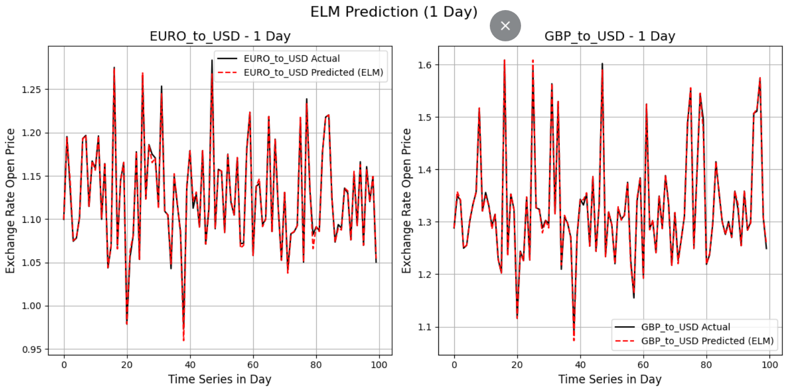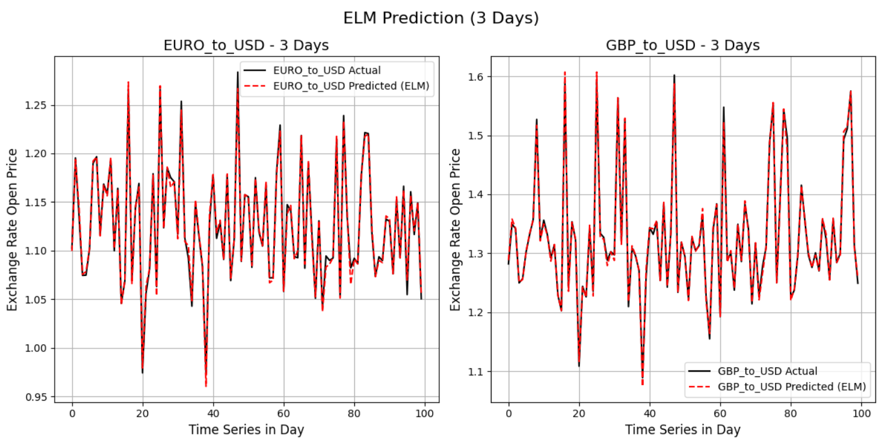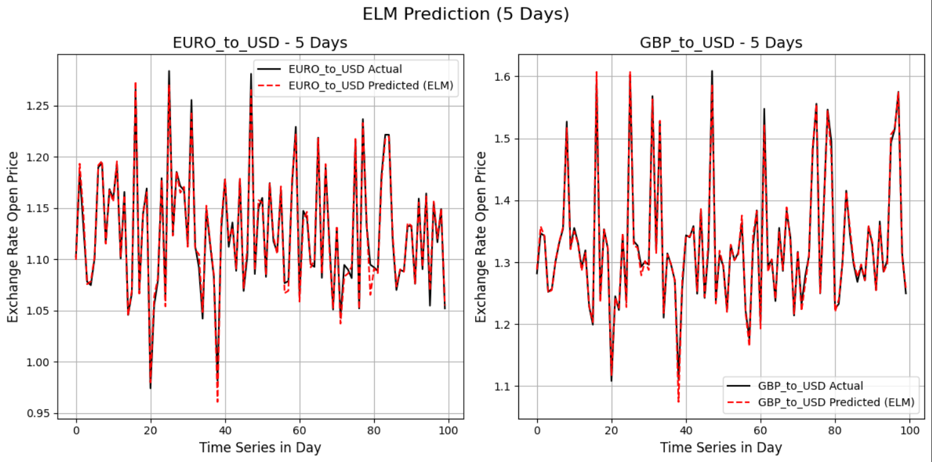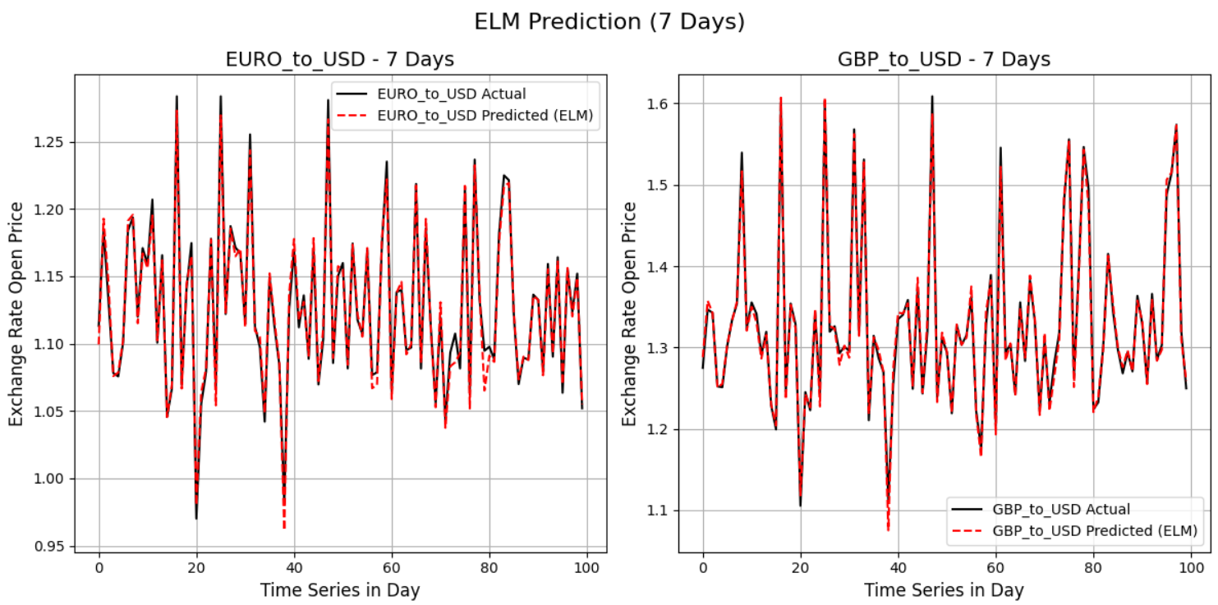

BPNN Graphs:

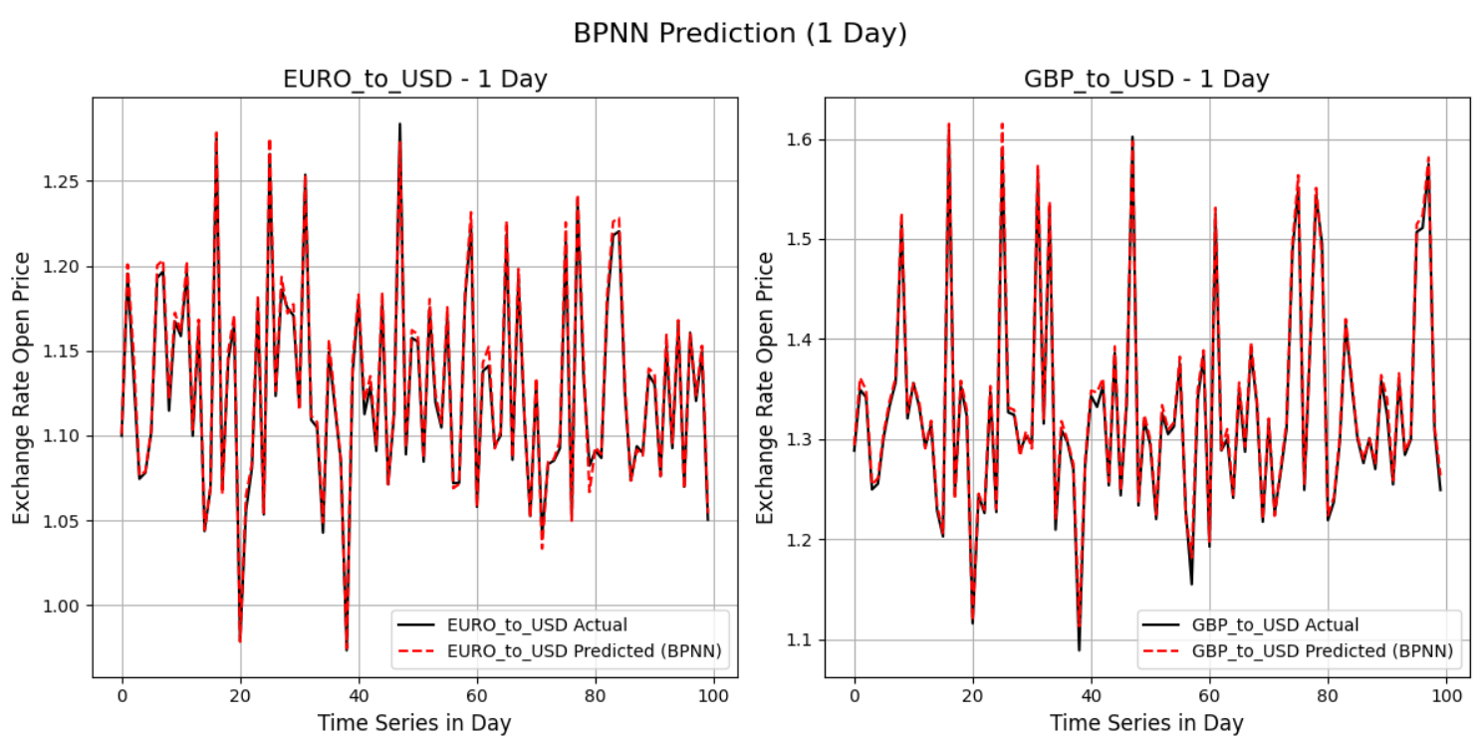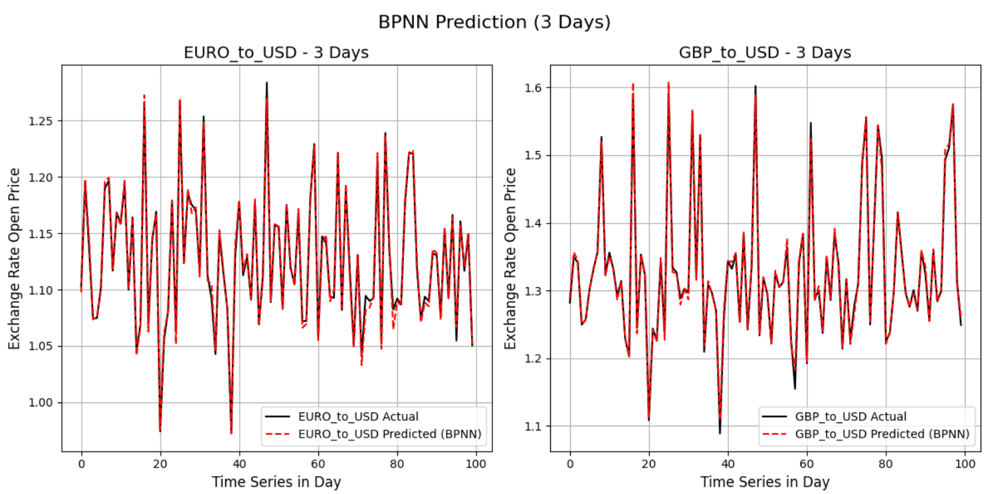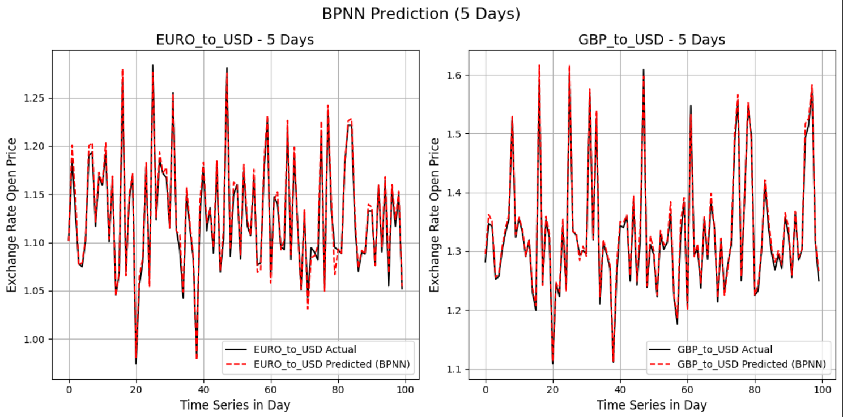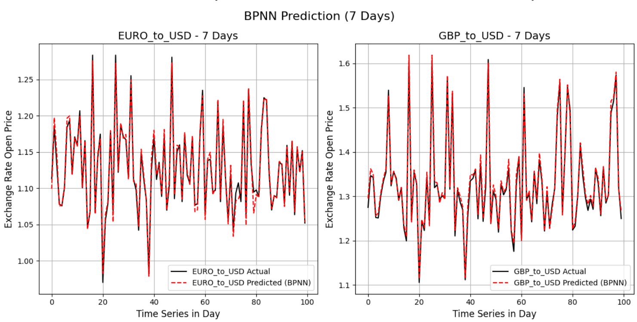

FLANN Graphs:

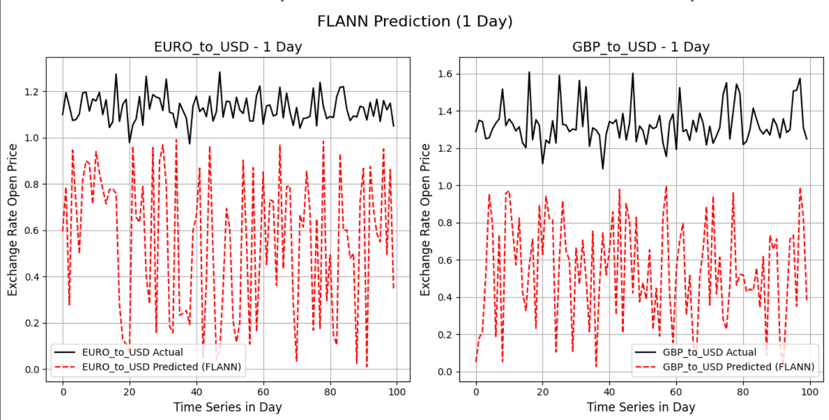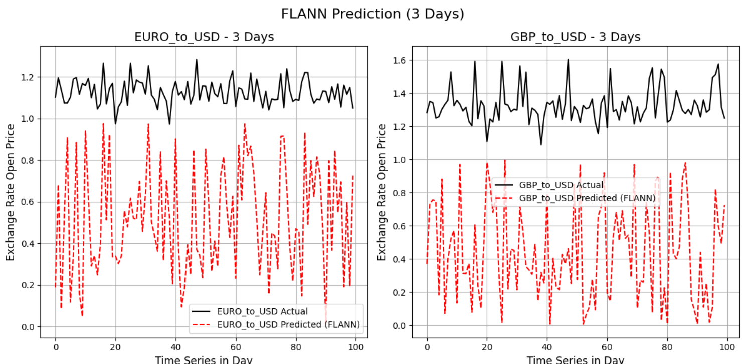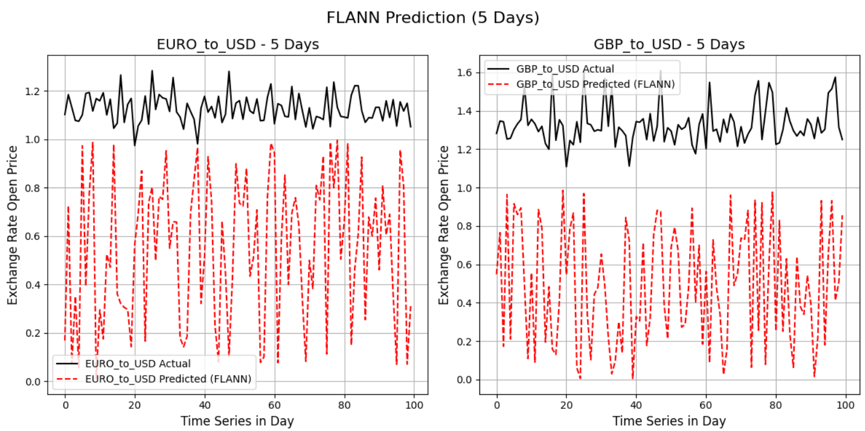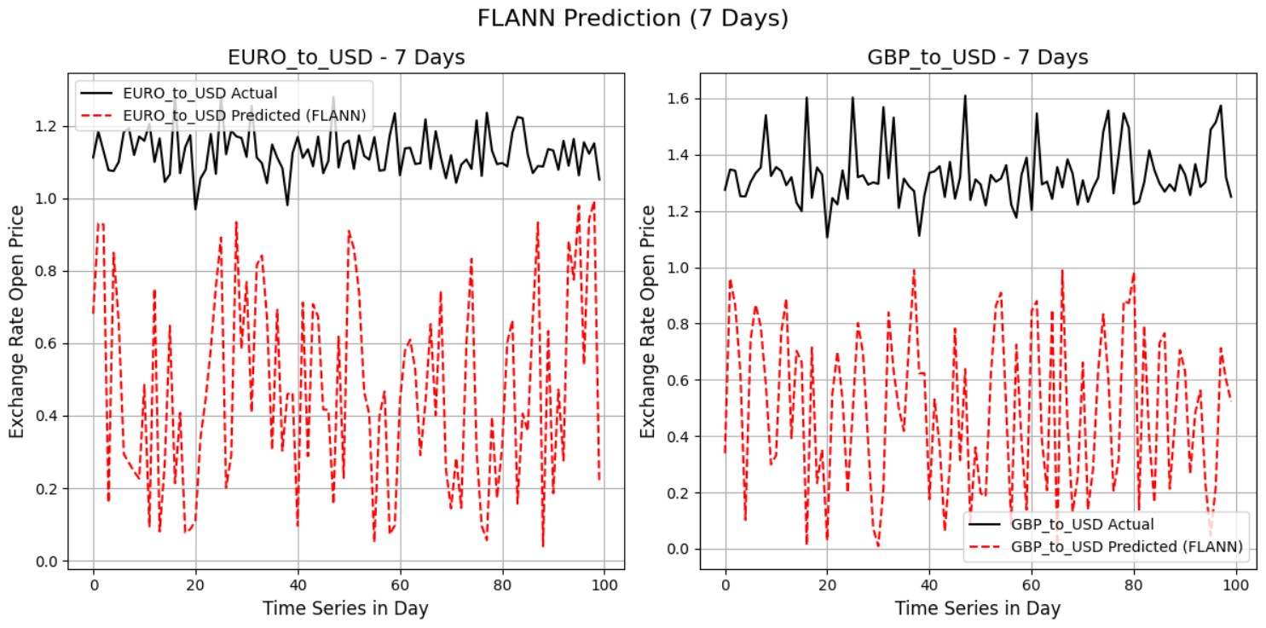

**REFERENCES:**

|  |  |
| --- | --- |
| **1.** | Sampath, M. K. T. "PREDICTING FOREX PRICE MOVEMENTS USING TWITTER SENTIMENT AND TECHNICAL INDICATORS." (2024). |
| **2.** | Zafeiriou, Theodoros, and Dimitris Kalles. "Off-the-Shelf Neural Network Architectures for Forex Time Series Prediction come at a Cost." In *Proceedings of the 13th Hellenic Conference on Artificial Intelligence*, pp. 1-7. 2024. |
| **3.** | Navaei, Mahdi, and Mostafa Pahlevanzadeh. "Forecasting Next-Time-Step Forex Market Stock Prices Using Neural Networks." *Advances in Machine Learning & Artificial Intelligence* 5, no. 2 (2024): 1-10. |
| **4.** | Zafeiriou, Theodoros, and Dimitris Kalles. "Comparative analysis of neural network architectures for short-term FOREX forecasting." *Intelligent Decision Technologies* 18, no. 3 (2024): 2177-2190. |
| **5.** | Perla, Someswari, Ranjeeta Bisoi, and P. K. Dash. "A hybrid neural network and optimization algorithm for forecasting and trend detection of Forex market indices." *Decision Analytics Journal* 6 (2023): 100193. |
| **6.** | Mirjalili, Seyedali, and Andrew Lewis. "The whale optimization algorithm." *Advances in engineering software* 95 (2016): 51-67. |
| **7.** | Nasiri, Jhila, and Farzin Modarres Khiyabani. "A whale optimization algorithm (WOA) approach for clustering." *Cogent Mathematics & Statistics* 5, no. 1 (2018): 1483565. |
| **8.** | **Datasets:** |
| **8.1** | **GDP to USD:** <https://www.investing.com/currencies/gbp-usd> |
| **8.2** | **EURO to USD:**  <https://www.investing.com/currencies/eur-usd> |